Industrial Internet of Things (IIoT)
AEC – (LEA.D2)
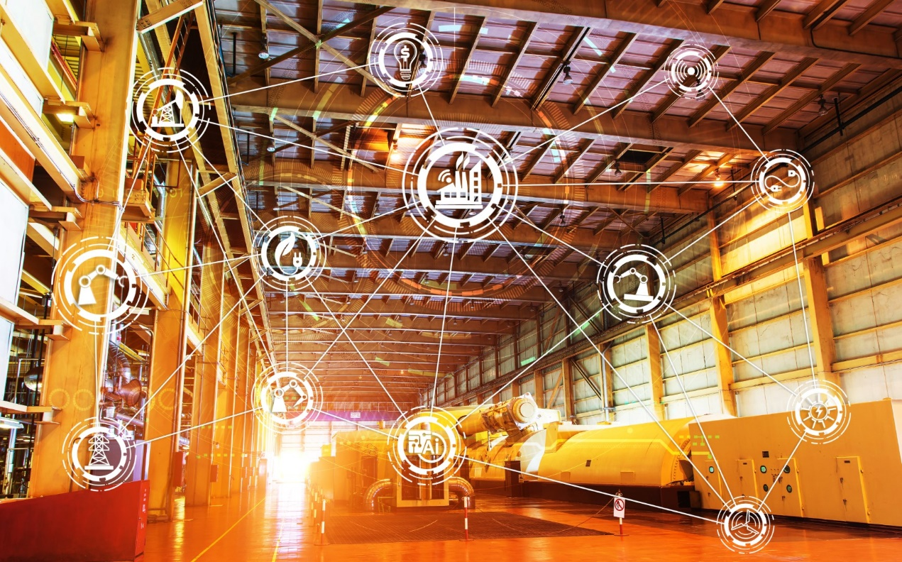

Contact Information:

Reem Talhamy (She/Her/Elle) Demetra Kargakos
Pedagogical Counsellor Pedagogical Counsellor
450-672-7360 ext. 3414 450-672-7360 x3433
rtalhamy@crcmail.net dkargakos@crcmail.net

Industrial Internet of Things (IIoT)
AEC – (LEAD2)

PROGRAM OBJECTIVE
The goal of this program is to enable students to begin successful careers in the emerging Industrial IoT domain and to provide them with a sound foundation for further education and career development. This AEC is designed to train technicians specifically in industrial grade IoT; they will be tasked with installing, configuring, maintaining, troubleshooting, and optimizing both the IoT devices as well as the infrastructure those rely on.
IoT technicians may be called upon to:
- select the appropriate sensors, IT infrastructure devices, databases, and specialized software used in connection with IoT;
- ensure communication can be established between machines or sensors and the IT infrastructure;
- ensure data can be stored and processed onsite or in the cloud;
- ensure analysis tools can be set up and configured for decision making;
- ensure the maintenance, troubleshooting and security of the IoT components.

CAREER OUTLOOK
There are currently very few appropriately skilled workers to assist companies and/or municipalities with the complex transition towards the integration of IoT into their environment. Many manufacturing companies in Quebec would like to take advantage of the benefits of moving from traditional manufacturing to a connected model, “Industry 4.0”, where the machines on the shop floor connect to their IT infrastructure to increase their company’s productivity. Municipalities are also seeking to increase their efficiency in areas such as optimized transport using connected sensors and displays, as they strive to become “smart cities”. Graduates from this AEC in IIoT will fill the void for skilled workers in this domain; they will find employment either directly in large and medium-sized manufacturing companies currently using or in migrating to IoT, as well as municipalities who are using or migrating to IoT. Graduates may also work for companies that specialize in industrial IoT consulting and deployment.

TARGETED CLIENTELE
The Industrial Internet of Things AEC (LEA.D2) is primarily directed at those currently working in the information technology sector who have experience with IT or Operational Technology (OT), networking, IT client support or electronics and wish to obtain specialized skills in IIoT. Candidates may currently be working in areas such as technical support or network administration. Candidates coming from fields such as electronics will require demonstrated knowledge of networking fundamentals.
ADMISSION CRITERIA
You are eligible to register in an Attestation of Collegial Studies (AEC) program if you are a Canadian Citizen or Permanent Resident or the holder of a valid Student Visa, and if you have the following:
- A Diploma of High School Studies OR
- A College Diploma or a University Degree OR
- A partial high school program, coupled with a recommendation from a current or former employer that you would benefit from pursuing your education at the post-secondary level.
AND
You meet one of the following three conditions:
- You have not been a full-time student for at least two consecutive terms or one school year within the last 12 months.
- You are part of an agreement between the college and an employer, or you are sponsored within the terms of a government program (EMPLOI-QUÉBEC).
- You have completed at least one year of post-secondary studies spread over a period of one year or more.

Specific requirements

In addition to the general admission requirements, the following requirements apply specifically to this program:
- Demonstrated schooling and/or work experience involving IT or OT
- Mathematics (either Secondary IV, Technical and Scientific option; or Secondary IV, Science option; or Secondary V, Cultural, Social and Technical option, or equivalent)
Applicants will be asked to submit their curriculum vitae (CV).
Note: Entrance exams may be administered. Applicants may be interviewed for English-language proficiency. They must have attained a certain level of mastery of the English language, in order to be able to deal with the course content.

Potential candidates may be required to take an appropriate remedial course(s).

GENERAL INFORMATION
Total number of hours: 780 hours

Start date: Winter 2023
Length of the program: Four semesters
Schedule: Mondays, Tuesdays, Thursdays (6:00pm to 9:30pm)
And Some Saturdays (9:00 a.m. to 4:00 p.m.)
Delivery method: Hybrid Mode of Delivery: In-class (lab mostly on Saturdays) and online instructor-led classes on Zoom

PROGRAM CONTENT

The IIoT AEC program targets the acquisition of the following competencies:

BJ1T Analyze information about the IoT and IIoT sectors
00Q2 Use programming languages
00Q6 Use an object-oriented development approach
BJ2T Set up wired components of a network in an IIoT context
BJ3T Implement wireless communication for IIoT
BJ4T Analyze operational technology (OT) network functions
BJ5T Set up communication interfaces with industrial systems
BJ0T Program control units
BJ6T Manage IIoT data
BJ7T Implement a cloud computing solution for an IIoT scenario
BJ8T Program SQL queries
BJ9T Automate operations using IoT systems
00SE Interact in a professional setting

Course Number | Course Title | Hours
420-950-LA | Introduction to the Profession | 60
420-951-LA | Introduction to Programming | 60
420-953-LA | Networking for IIoT | 75
243-960-LA | Introduction to Operational Technology (OT) Networks | 75
420-952-LA | Applied Object-Oriented Programming for IIoT | 45
420-954-LA | Advanced Networking Applied to IIoT | 75
243-990-LA | Programmable, Intelligent, and Connected Devices | 60
420-956-LA | IIoT Data Management | 75
420-957-LA | Cloud and Big Data Solutions for IIoT | 60
420-960-LA | Data Analysis, Visualization, and Task Automation | 90
420-961-LA  or  420-962-LA | Final Project  or  Internship | 105
FEES
Application Fee (new student) $30.00
Registration Fee ($150.00 per semester x 4 semesters) $600.00 *
Books and resources $700.00 **

*Fees may vary depending upon Québec Residency Status
**Fees are approximate

Please note that if you choose to withdraw from a course(s) or if you fail a course(s), it may affect your student status and you may have to pay tuition fees – (Example - a $25.00 registration fee per course). Also, by withdrawing from a course(s) or failing a course(s) within your Attestation program, it may make it difficult or impossible for you to continue with your program at that time, it may delay you in the completion of your program, or it may hinder your opportunity to complete the program.
Information and fees are subject to change.
To ensure that our graduates are competitive in the market place, the College reserves the right to modify portions of this program at any time.
COURSE DESCRIPTIONS
INTRODUCTION INTO PROFESSION 420-950-LA
Prerequisite: None
This introductory course will enable learners to leverage their technical knowledge across IoT environments. In this course, we will introduce the concept of IoT. We will explore the ‘things’ that make up the Internet of Things, including how those components are connected together, how they communicate, and how they add value to the data generated. We will also examine the IoT data analysis, security, privacy and optimization of the IIoT scenarios. The students will briefly review the most common IoT uses-cases and the interaction between the IIoT devices and digital transformation of industries.

INTRODUCTION TO PROGRAMMING 420-951-LA
Prerequisite: None
This course will introduce the students to the basics of Python programming. The goal of the course is to introduce students to basics of Python programming using hands-on experience.
Students will learn how to install Python and use different IDEs (Integrated Development Environment) such as PyCharm for writing and debugging programs. The students will also learn to use Python and Jupyter platforms on Raspberry Pi. They will receive the tools necessary to create basic programs and resolve simple problems. Students will apply Python built-in data structures such as lists, dictionaries, and tuples to perform data analysis. Functions, classes and basic libraries of Python will also be covered in this course. After completing this course, students will be ready to take more advanced programming courses in Python.

NETWORKING FOR IIOT 420-953-LA
Prerequisite: None
This course provides the students a full overview of wired computer networking as it relates to IoT. They will have an opportunity to design, implement, and support a LAN network in an IoT setting. By the end of the course, students will be able to build simple LANs, perform configurations on routers and switches, and implement IP addressing schemes using both equipment and emulators.

INTRODUCTION TO OPERATIONAL TECHNOLOGY (OT) NETWORKS 243-960-LA

Prerequisite: None
In the course, students will be introduced to the components and specifics of OT networks commonly found in a manufacturing environment. Students will have the opportunity to set up and establish communication, as well as retrieve and log data from an industrial control unit.

APPLIED OBJECT-ORIENTED PROGRAMMING FOR IIOT 420-252-LA
Prerequisite: 420-951-LA
This course will introduce students to the technical approach used for analyzing and designing an application by applying object-oriented programming. Students will develop the ability to select and use programming languages, desktop Integrated Development Environment (IDE) Software Development Kits (SDKs) and Application Programming Interfaces (APIs) for an IIoT environment. Students will also learn to program IoT devices using Arduino and Raspberry Pi platforms with the purpose to control the physical world (various sensors and actuators like, LED module, Motion Sensor, DHT22 Temperature and Humidity Sensor, Digital push button). The Raspberry Pi is typically installed with a Linux-based operating system, so the basics of Linux and its use will be introduced to the students as well as some of its main features including navigating the file system and managing processes. Students will be exposed to the text-based user interface through the shell and have an overview of the graphic user interface that is the default with the Raspian Linux distribution.

ADVANCED NETWORKING APPLIED TO IIOT 420-954-LA

Prerequisite: 420-953-LA and 243-960-LA

This course provides the students an opportunity to design and implement wireless technology, test wireless communications, optimize wireless transmission and support a wireless network in an IIoT setting in compliance with regulations.

PROGRAMMABLE, INTELLIGENT, AND CONNECTED DEVICES 243-990-LA

Prerequisite: 420-953-LA and 243-960-LA

In this class, students will learn how to integrate external devices (sensors, motors, GPS, orientation, LCD screens etc.) with the IIoT system to get an IoT device to interact with the real world. Students will use embedded systems, build hardware systems and connect devices to control the environment. They also learn methods to secure the IoT devices. Simple implementation of Industry 4.0 processes such as Digital Twin will also be covered in this course.

IIoT Data MANAGEMENT 420-956-LA
Prerequisite: None
This course will provide students with the necessary skills to securely extract, transform and load IIoT Data and DataSets to IIoT oriented Databases in conformity with Industrial Data classification models and Security best practices. Students will explore relational and non-relational databases as well as how to use local or cloud-based IIoT Data ETL (Extract, Transfer & Load) solutions and platforms.

CLOUD AND BIG DATA SOLUTIONS FOR IIOT 420-957-LA

Prerequisite: 243-990-LA

This course will provide students with the skills required to use cloud computing in various modes (SaaS, PaaS, etc.) in an IIoT environment. This course describes how to connect, set up and use of cloud resources, e.g. EC2 (Elastic Compute Cloud) for IoT scenarios to enhance the performance of IoT solutions and to better analyze the IoT data. Different services such as telemetry and its relation to the IoT services will be covered in this course. Students will learn to locate IoT services in the cloud and acquire knowledge of the basic steps for setting it up. Moreover, in this course, students will learn to develop a simple IoT application to send and receive data to/from the cloud and to structure the IoT app with a variety of different cloud services. Briefly, this course will help students to integrate the embedded systems into the cloud.

DATA ANALYSIS, VISUALIZATION, AND TASK AUTOMATION 420-969-LA

Prerequisite: 420-957-LA

This course provides students with an opportunity to transform IoT data to enhance the performance of industrial operations. This course will expose students to the data analytics practices executed in the Industrial IoT. They will move from the stages of problem identification to planning and applying a variety of data-driven solutions. They will learn to work with data and create an environment in which analytics can flourish. Students will learn how to manipulate and analyze IoT data and explore different use cases in IoT. For instance, they will learn to retrieve data from databases (Static, Real-time) using queries. The basics of Machine Learning for IoT data analysis will be covered. Students will also learn how to use common visualization tools. They will discover how data visualization can be used to better present the IoT data. They will explore the fundamental concepts of data visualization common interfaces and dashboards such as Power BI and Kibana, identifying and applying the various tools dashboards offer. By the end of the course, students will be able to prepare and import data into tables and explain the relationship between data analytics and data visualization.
Students will learn the steps involved in automating tasks based on predetermined conditions. They will also learn about Intelligent Process Automation (IPA) and common event-driven task automation approaches with a focus on applications in a variety of IIoT systems.
FINAL PROJECT 420-961-LA

Prerequisite: 420-960-LA

In the final capstone project completed in small groups of 2-3 students, students will apply the skills they have learned, by designing, building, controlling and testing in a controlled experimentation environment (IIoT testbed), as well as by collecting, storing, analyzing and visualizing the IIoT data. There will be an emphasis on ensuring that the final project is suitable as a showcase to future employers.

Or

INTERNSHIP 420-962-LA

Prerequisite: 420-960-LA

An internship experience provides the student with an opportunity to explore career interests while putting in practice knowledge and skills acquired in the program in a work setting. This course with help students to identify the practical issues of IIoT and provide a better platform to work with technological solutions. The internship provides hands-on training to effectively use and customize device interactions, networks, data management and analysis. Students will understand the essentiality of inter-connected devices and the benefits of task/process automation in industry. Students will get an overview of IoT application deployment in industry. The experience also helps students gain a clearer sense of future learning direction to adapt their knowledge and skills and provides an opportunity to build professional networks.

Champlain College’s State-of-the-art IIoT lab:
